**AE 210 – AE Professional Topics**

**Assignment 1.1**

**Ben P. Baker**

**Submitted February 8, 2024**

**Finding A Mentor: Initial Mentor Selection**

1. POSSIBLE MENTORS
2. *Sean Taylor*

Sean Taylor is currently the Director of Partnerships for Starlink at SpaceX (see Fig. 1 for a promotional photo of the technology he directs partnerships for) and has a history in Project Management and Systems Engineering. He has specialized in wireless communication - whether video streaming, aviation communications technology, or Direct to Cell technology.

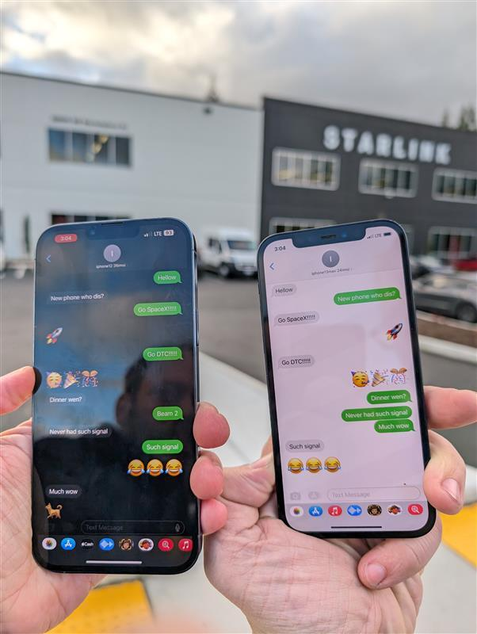

Figure 1. Promotional Photo of Starlink Direct to Cell Technology [1].

1. *Louis Peters*

Louis Peters currently is the Director of Customer Experience and Innovation at Publicis Sapient and has a history of Consulting, Project Management, and Digital Transformation. Although their career has focused on the managerial and business aspects of software engineering, he was largely focused on making interdisciplinary projects successful.

1. *Carl Yoder*

Carl Yoder is currently a student at the University of Louisville pursuing a bachelor’s degree in electrical and Electronics Engineering. He is involved in the university as an undergraduate research assistant, is in the Assisted Robotics Research at UofL, and built systems for a nursing robot and multiple social robot experiments.

1. CONNECTIONS TO MENTORS
2. *Sean Taylor*

Sean Taylor is the cousin of my parents and grew up with them in Ohio. I can get in contact with him through his cell phone number in addition to his LinkedIn profile.

1. *Louis Peters*

Louis Peters is the President of the Engineers of Tomorrow, the First Robotics Competition (FRC) team I was a part of during high school. I can get in contact with him through the team’s Slack group, of which I am still a part of.

1. *Carl Yoder*

Carl Yoder was a member of the Engineers of Tomorrow during the four years before I was a member, and he occasionally would help me with troubleshooting issues the Systems team I led came across. I can get in contact with him through the team’s Slack group.

1. METHOD OF MENTOR SELECTION
2. *Selection Process*

The process of selection for possible mentors initially followed the advice given by Dr. Aaron Doug during the lecture presentation [2], where priority should be given to the mentors you have an ability to easily contact or would be more likely to sit through an interview. Therefore, I first looked to the people I know I had close contact with that currently are pursuing degrees in engineering (or another STEM field) or are currently or were previously in STEM fields. From that list, priority was given both to the possible mentors that would be most likely to want to participate in an interview and to those who had previous experience in either aerospace or aviation fields.

1. *Mentor Selection Justification*

Sean Taylor was chosen because he is currently employed in one of the largest and most famous aerospace companies, SpaceX, his prior experience in handling aviation communications projects, and due to the family connection (where the likelihood of receiving a response is much higher).

Louis Peters was chosen due to his prior experience working with software engineers in addition to him having a personal liking towards me due to my heavy involvement in the Engineers of Tomorrow. The interdisciplinary nature of his work provided more interest in his interview responses.

Carl Yoder was chosen due to his relative proximity to my current position in my engineering education and career, but his advice for the next few years will be the most up-to-date. While getting ahold of Carl (during prior FRC seasons or off-seasons) often required a few days’ grace, he was consistent in replying once he was aware the team needed assistance.

**References:**

1. Taylor, S. “Ready to transform your MNO’s future in ’24?” January, 2024, https://www.linkedin.com/feed/update/urn:li:activity:7153444707883208705/?updateEntityUrn=urn%3Ali%3Afs_updateV2%3A%28urn%3Ali%3Aactivity%3A7153444707883208705%2CFEED_DETAIL%2CEMPTY%2CDEFAULT%2Cfalse%29 (accessed January 8, 2024).
2. Doug, A, private communication, Feb. 2024.